DevOps day-7
1.View environment variables
env command is used to check the default environment variables
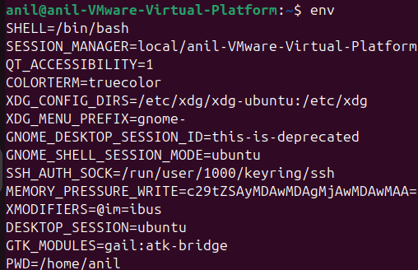
2.Create custom variables.
To create customized environment variables, export command variable name

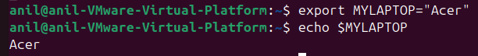
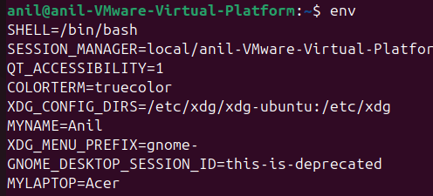
3.Modify PATH variable
We can use export command to add new path to PATH variable
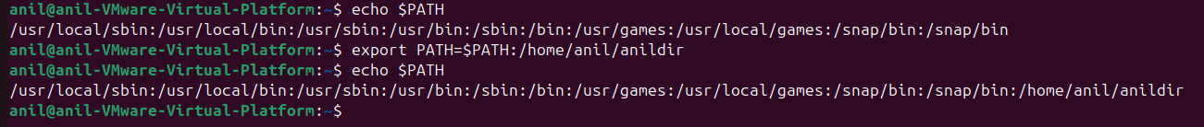
4.Make Variables persistent
If we want permanent the variable we can use the .bashrc for single user we can /etc/profile for all users
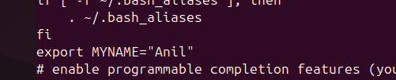
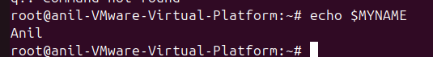
5.Test Changes
After change the variable in .bashrc and restart the laptop and we can check variable
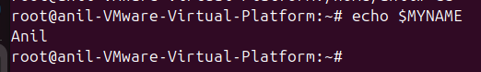
6.Debug PATH issues
If any PATH issue are there we can check the command to locate the command path whereis command and copy the path and export the path
